MODULE-01

INDIVIDUAL TASK-01

Working of Artificial Neural Networks (ANN)
1. Introduction to Artificial Neural Networks
Artificial Neural Networks (ANNs) are computational models inspired by the structure and working of the human brain. Just like the human brain contains billions of neurons connected to each other, ANNs consist of artificial neurons connected through weighted links.ANNs are a core technology in Artificial Intelligence (AI) and Machine Learning (ML). They are designed to recognize patterns, learn from data, and make decisions with minimal human intervention.The early foundation of neural networks was laid by Frank Rosenblatt, who introduced the Perceptron model in 1958. Modern deep learning advancements were significantly improved by researchers such as Geoffrey Hinton.
2.Biological Inspiration of ANN:-
Artificial Neural Networks are inspired by biological neurons.
2.1 Biological Neuron Structure:
- Dendrites → Receive signals
- Cell Body → Processes signals
- Axon → Sends signals

2.2 Artificial Neuron Equivalent:
- Inputs → Receive data
- Weights → Strength of signal
- Summation Function → Adds weighted inputs
- Activation Function → Produces output
Thus, ANN mimics how the brain processes and transmits information.

3.Structure of Artificial Neural Network
An ANN is composed of layers of neurons:

3.1 Input Layer
- The first layer of the network.
- Receives raw input data.
- Each neuron represents one feature of the dataset.
- Example: For image input, each pixel may act as one input neuron.
- 3.2 Hidden Layer(s)
- Located between input and output layers.
- Responsible for performing complex calculations.
- Extracts patterns and features from data.
- A network may have one or multiple hidden layers.
- More hidden layers = Deep Neural Network (DNN).

3.3 Output Layer
- Final layer of the network.
- Produces prediction or classification result.
- Example:
  - 0 or 1 (Binary classification)
  - Multiple categories (Multi-class classification)
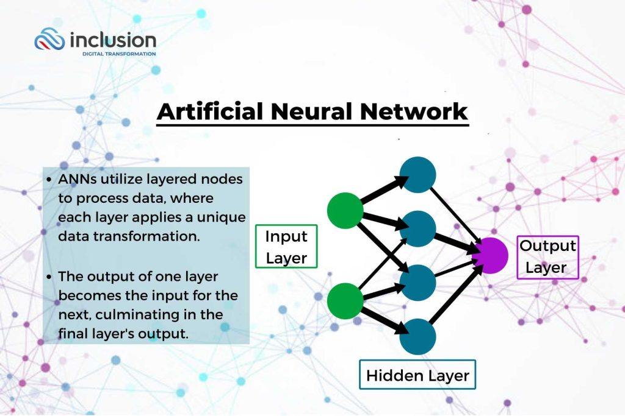

4.Components of an Artificial Neuron
Each artificial neuron contains the following components:

4.1 Inputs (x1, x2, x3, …)
These are the values received from the input layer or previous hidden layer.

4.2 Weights (w1, w2, w3, …)
- Each input has a corresponding weight.
- Weights determine the importance of each input.
- Higher weight → More influence on output.

4.3 Bias (b)
- A constant value added to the weighted sum.
- Helps shift the activation function.
- Improves flexibility of the model.

4.4 Summation Function
Calculates weighted sum of inputs:
Z = (x1w1 + x2w2 + x3w3 + … + xnwn) + b

4.5 Activation Function
- Converts the weighted sum into output.
- Decides whether neuron should activate or not.

5.Activation Functions
Activation functions introduce non-linearity into the model.

5.1 Sigmoid Function
- Output range: 0 to 1
- Used in binary classification problems
- Formula: 1 / (1 + e^(-x))

5.2 ReLU (Rectified Linear Unit)
- Output = max(0, x)
- Most commonly used in hidden layers
- Helps solve vanishing gradient problem

5.3 Tanh Function
- Output range: -1 to 1
- Centered around zero

5.4 Softmax Function
- Used in multi-class classification
- Converts outputs into probability distribution

6.Working Process of ANN (Step-by-Step)
The working of ANN happens in two main phases:

6.1 Forward Propagation
- Input data is fed into the network.
- Each neuron calculates weighted sum.
- Activation function is applied.
- Output is generated.
- Data moves layer by layer (left to right).
6.2 Loss Calculation
- The predicted output is compared with actual output.
- The difference is called Error or Loss.
- Common Loss Functions:
  - Mean Squared Error (MSE)
  - Cross-Entropy Loss

6.3 Backpropagation
- Error is sent backward through the network.
- Partial derivatives are calculated.
- Gradient Descent algorithm adjusts weights.
- Goal: Minimize error.
This process repeats for many iterations called epochs until the network learns properly.

7.Training of Neural Network
Training involves:
- Initializing random weights
- Performing forward propagation
- Calculating loss
- Applying backpropagation
- Updating weights
- Repeating the process
Optimization algorithms include:
- Gradient Descent
- Stochastic Gradient Descent (SGD)
- Adam Optimizer

8.Types of Artificial Neural Networks

8.1 Feedforward Neural Network (FNN)
- Simplest type.
- Data flows in one direction only.

8.2 Convolutional Neural Network (CNN)
- Mainly used for image processing.
- Detects patterns like edges and shapes.

8.3 Recurrent Neural Network (RNN)
- Used for sequential data.
- Remembers previous information.
- Used in speech recognition and text generation.

8.4 Deep Neural Network (DNN)
- Network with multiple hidden layers.
- Used in complex AI systems.
Organizations such as OpenAI use deep neural networks to build advanced AI systems.

9.Applications of ANN
Artificial Neural Networks are widely used in:
- Image Recognition
- Face Detection
- Speech Recognition
- Language Translation

10.Advantages of ANN
- Can learn complex and non-linear relationships
- Self-learning capability
- High accuracy
- Works well with large datasets

. 11.Disadvantages of ANN
- Requires large amount of training data
- Computationally expensive
- Requires powerful hardware (GPU)
- Difficult to interpret (Black Box problem)
- Risk of overfitting
12.Conclusion
- Artificial Neural Networks are powerful machine learning models inspired by biological neurons. They work by processing inputs through weighted connections, applying activation functions, calculating errors, and adjusting weights using backpropagation. With advancements in deep learning, ANNs have become the backbone of modern Artificial Intelligence systems.

